Assignment 3:

Volere Card:

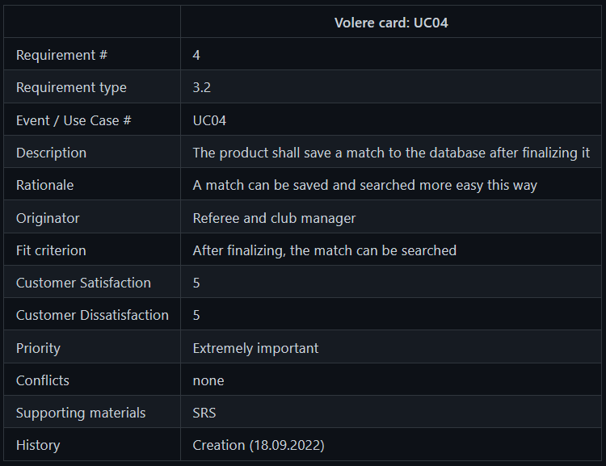

Visual Paradigm Structure:

No structure, because the code has expired and I can't use VP anymore. As soon as I have a new code, I will do and upload it.